Customer Interview report

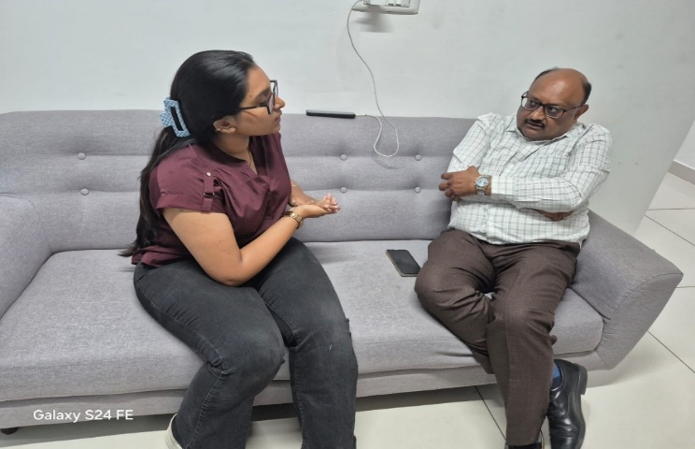
Project-Based Business Perspective (Naptico)
Businesses operating in project-based environments frequently deal with vendor contracts and loan agreements, where the major challenge occurs at the pre-contract decision stage.
They highlighted that:
- Contracts contain complex legal and financial terms
- It is difficult to clearly understand payment structures, penalties, and interest implications
- There is uncertainty about the total financial impact and long-term consequences
The key insight identified was:
The problem is not just understanding contracts, but knowing the financial risks and impact before signing.
How the system helps:
- Provides simplified explanations of complex contract terms
- Performs financial impact analysis to show total cost and long-term burden
- Detects risks and penalties, helping users evaluate contracts before signing
Questions asked by the customer & answers:
Q1: How will your system understand vendor and loan contracts?
Answer:
The system uses NLP and pattern recognition to identify key elements like payment terms, penalties, and obligations, which are common across vendor and loan agreements.
Q2: How will your system calculate financial impact?
Answer:
It extracts financial data such as interest rates, payment schedules, and penalties, then applies financial logic to calculate total cost and long-term impact.
Q3: Can your system identify risks before signing?
Answer:
Yes, it detects penalty clauses, hidden charges, and unusual terms, helping users evaluate risks before making decisions.
Q4: Will your system work for contracts with different formats?
Answer:
Yes, because it focuses on patterns rather than fixed formats, allowing it to handle different contract structures.
Contract Handling Perspective (Amrutha Associates)

Businesses dealing with multiple agreements face challenges in handling and interpreting contract terms accurately and efficiently.
They highlighted that:
- There is a need for clarity and accuracy in contract terms
- Misinterpretation of financial clauses can occur
- Managing multiple agreements becomes difficult and time-consuming
They emphasized that even small misunderstandings in contracts can lead to:
- Financial discrepancies
- Disputes with suppliers
- Operational inefficiencies
How the system helps:
- Analyzes contracts quickly and provides clear summaries
- Highlights important clauses and potential risks
- Ensures better interpretation and understanding of financial terms
Questions asked by the customer & answers:
Q1: How will your system analyze multiple contracts efficiently?
Answer:
The system automates contract analysis, providing quick summaries and key insights, which helps handle multiple agreements efficiently.
Q2: Can your system highlight important clauses clearly?
Answer:
Yes, it extracts and highlights key clauses such as financial terms, obligations, and risks for easy understanding.
Q3: Will the system be accurate and reliable?
Answer:
It provides high accuracy in identifying key details and risks, acting as a reliable support tool for contract evaluation.
Q4: Will this system be useful in daily business operations?
Answer:
Yes, it improves speed, clarity, and efficiency, making contract handling easier and more reliable.

AI-Based Contract Intelligence Perspective (Chetan – CA Auditor & Tech-Savvy Professional)
A Chartered Accountant and auditor with strong software knowledge highlighted challenges while analyzing agreements and evaluating AI-based solutions for contract understanding.
They highlighted that:
• General AI tools like ChatGPT provide generic responses without domain-specific accuracy
• Contracts require clear interpretation of financial terms, liabilities, and obligations
• There is no system that learns from past contract analysis to improve future insights
The key insight identified was:
The problem is not just analyzing contracts, but delivering accurate, reliable, and continuously improving insights for better decision-making.
How the system helps:
• Uses domain-specific NLP models to understand legal and financial clauses
• Incorporates learning from previous contracts to enhance accuracy over time
• Provides risk detection, financial impact analysis, and decision-oriented insights
Questions asked by the customer & answers:
Q1: How is your system different from tools like ChatGPT?
Answer:
Unlike ChatGPT, the system is domain-focused and decision-oriented. It goes beyond text generation to provide risk analysis, financial insights, and structured contract understanding.
Q2: How will your system understand vendor and loan contracts?
Answer:
The system uses NLP and pattern recognition to identify key elements like payment terms, penalties, and obligations, which are common across vendor and loan agreements.
Q3: Can your system identify risks before signing?
Answer:
Yes, it detects penalty clauses, hidden charges, and unusual terms, helping users evaluate risks before making decisions.
Q4: Will your system work for contracts with different formats?
Answer:
Yes, because it focuses on patterns rather than fixed formats, allowing it to handle different contract structures effectively.

Retail Pharmacy Business Perspective (Khushi Medico)

Interview conducted with: Mr. B.R. Mahesh (Owner, Khushi Medico, Bangalore)
Retail pharmacy businesses deal with supplier agreements, purchase contracts, and credit-based transactions, where understanding financial and contractual terms is very important.
They highlighted that:
- Supplier agreements include complex pricing, discounts, and credit terms.
- Difficulty in tracking payment deadlines, penalties, and interest.
- Lack of clarity in bulk purchase and return policies.
- Managing multiple supplier contracts is time-consuming.
The key insight identified was:
The problem is not just understanding agreements, but clearly evaluating pricing, credit terms, and financial impact before making purchasing decisions.
How the system helps:
- Simplifies supplier agreements into clear and easy language
- Calculates total cost including discounts, taxes, and credit interest
- Identifies risks such as hidden charges and penalties
- Helps compare supplier contracts for better decision-making
Questions asked by the customer & answers:
Q1: How will your system understand pharmacy supplier agreements?
Answer:
The system uses NLP techniques to identify key elements like pricing, discounts, credit terms, and return policies commonly found in supplier agreements.
Q2: How will your system calculate financial impact?
Answer:
It analyzes pricing, tax details, discount structures, and credit terms to estimate the total cost and any additional financial burden.
Q3: Can it help in choosing better suppliers?
Answer:
Yes, it compares different supplier agreements and highlights the most cost-effective and beneficial options.
Q4: Can it detect risks in agreements?
Answer:
Yes, it identifies hidden charges, penalty clauses, and strict return policies that may negatively impact the business.
Q5: Will it be useful in daily operations?
Answer:
Yes, it improves clarity, reduces errors, and supports faster and more confident decision-making.
Q6: How is your app different from existing solutions?
Answer:
Unlike existing tools that only provide basic contract summaries or general information, this system focuses on both contract understanding and financial impact analysis. It not only explains terms in simple language but also calculates total cost, highlights risks, and supports better decision-making, making it more practical for daily business use.

QA Engineer Perspective (Lakshmi Charithanjali)
QA professionals working in IT environments frequently deal with technical documents and contracts, where the major challenge occurs during contract review and validation stages.
They highlighted that:
- Contracts are lengthy and time-consuming to review
- It is difficult to quickly identify hidden risks and important clauses
- Manual analysis leads to repetitive work and inefficiency
The key insight identified was:
The problem is not just reviewing contracts, but efficiently identifying risks and ensuring accuracy within limited time.
How the system helps:
- Provides quick summarization of lengthy contract documents
- Identifies key clauses and highlights potential risks
- Automates analysis to reduce manual effort and improve efficiency
Questions asked by the customer & answers:
Q1: How will your system handle large and complex contract documents?
Answer:
The system uses NLP techniques to break down large documents into structured information and generate concise summaries for quick understanding.
Q2: How will your system improve efficiency in contract review?
Answer:
It automates repetitive analysis tasks and highlights key sections, reducing the time required for manual review.
Q3: Can your system detect hidden risks or clauses?
Answer:
Yes, it identifies unusual terms, critical clauses, and potential risks that may be overlooked during manual review.

Q4: Will your system integrate with existing workflows?
Answer:
Yes, it is designed to work alongside existing tools and processes without disrupting the workflow.

Business Owner Perspective (Sri Sai Surya Prakash filling station & Sri Raghavendra Marketing and agency )
Interview conducted with: Prasad Reddy (Owner, Sri Sai SuryaPrakash filling station and Raghavendra marketing and agency, Kavali)
Business owners managing operations frequently deal with vendor agreements and official documents, where the major challenge occurs at the understanding stage before signing.
They highlighted that:
- Contracts are difficult to understand due to complex English language
- It is hard to interpret legal terms without external help
- There is dependency on others for explaining documents
The key insight identified was:
The problem is not just reading contracts, but clearly understanding them in a simple and accessible way before making decisions.
How the system helps:
- Provides simplified explanations of complex legal terms
- Supports multilingual understanding for better clarity
- Generates quick summaries for easy decision-making
Questions asked by the customer & answers:
Q1: How will your system help users who are not comfortable with English?
Answer:
The system provides multilingual support and simplifies complex legal language into easy-to-understand terms.
Q2: How will your system reduce dependency on others?
Answer:
It automatically summarizes and explains contracts, allowing users to understand documents independently.
Q3: Can your system simplify complex legal terms?
Answer:
Yes, it converts legal jargon into simple, clear language for better understanding.
Q4: Will your system be easy to use for non-technical users?
Answer:
Yes, it is designed with a simple and user-friendly interface suitable for all users.
Q5: Can this system guarantee complete understanding of contracts?
Answer:
It provides strong support for understanding, but users may still consult experts for critical decisions.

Team Lead Perspective (Thulasi)
Team leads in enterprise IT environments frequently handle multiple contracts, vendor agreements, and compliance documents, where the major challenge occurs in managing, analyzing, and securing these documents efficiently.
They highlighted that:
- Managing multiple contracts simultaneously is complex
- Ensuring data security and confidentiality is critical
- Manual review is time-consuming and prone to errors
The key insight identified was:
The problem is not just managing contracts, but ensuring secure, accurate, and scalable analysis across multiple documents.
How the system helps:
- Provides scalable contract analysis for handling large volumes
- Ensures secure processing of sensitive documents
- Detects risks and supports compliance with accurate analysis
Questions asked by the customer & answers:
Q1: How will your system handle multiple contracts at scale?
Answer:
The system is designed to process and analyze multiple documents efficiently using scalable architecture.
Q2: How will your system ensure data security?
Answer:
It incorporates secure data handling practices and ensures confidentiality of sensitive documents.
Q3: Can your system help with compliance and regulations?
Answer:
Yes, it identifies key clauses and ensures contracts align with standard compliance requirements.
Q4: How accurate is the contract analysis?
Answer:
It uses advanced NLP techniques to provide high accuracy in identifying key information and risks.

